Name: Braden Seavoy

Student ID: 1222971230

Date: 7/3/2025

**Instructions:** You should **have at least three pages (3 html files and 1 css file) of your site completed by the time you submit this**. Use the following to have a written discussion about the current progress of your website. After you answer the questions below, insert a screenshot of each of the pages you have completed so far (remember, you should have at least 4 and the CSS file). Do NOT screenshot the html code because we can’t run the code. Save the file to yourasurite – Project Assignment – Project Update 2.docx file and yourasurite – Project Assignment – Project Update 2.pdf file. Submit both files to Canvas.

1. **How do you feel your website is coming along? (10 points)**

**It feels ok, I might try to mess around with the whitespace and formatting going forward but at the moment I am happy with the current design**

1. **Since your last update, have you encountered any issues? (4 points) If so, describe what they were and how you resolved them. (3 points) Are there any issues still unresolved? (3 points)**

I have not faced any issues and there are no unresolved issues

1. **Your final project is almost done, outline what you have left and how you plan on completing it: (10 points)**

I plan on adding the review forms, updating the contact info a little more, but not too much.

1. **List your project website's GitHub URL. (10 points)**

[**https://github.com/bgseavoy3/bseavoyCIS300FinalProject**](https://github.com/bgseavoy3/bseavoyCIS300FinalProject)

1. **Videos can be a powerful tool on websites, helping to engage visitors by providing visual demonstrations, tutorials, product showcases, or entertainment. They can enhance the user experience by offering dynamic content that complements text and images. Videos are especially useful for conveying complex information in an easy-to-understand format.**

**Where would you like to use videos on your website? (2 points) How many videos will you include, and what videos will you create? (2 points) What do you hope to achieve with them (6 points)**

**I would add video demos of how to use the application in each of the separate product sites. This would help users both see the features in real time and understand how to use them.**

1. **See your website’s readiness scores. Open your website in Chrome, right click your mouse to find Inspect. Click Inspect to find Lighthouse. Click Lighthouse to see the website’s readiness scores. Screenshot those scores and insert the Lighthouse report below: (10 points). The report should include performance, accessibility, Best Practices, and SEO scores.**

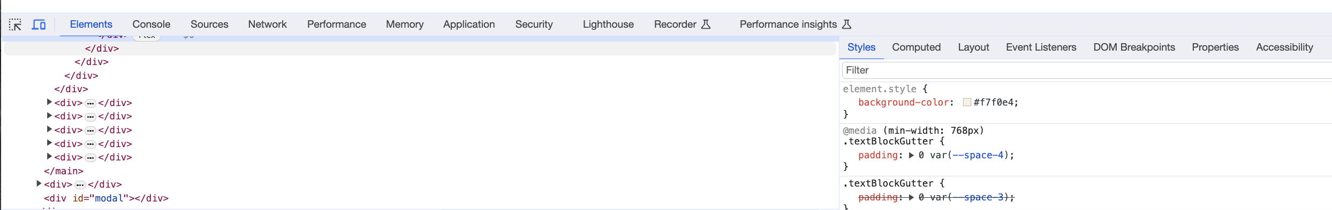

**Web page browser view screenshot of Page #1 (10 points)**

**Web page browser view screenshot of Page #2 (10 points)**

**Web page browser view screenshot of Page #3 (10 points)**

**screenshot of the CSS code (10 points)**

